**ASSIGNMENT 4**

**Q1-** Write a select command that produces the order number amount,date for all rows in the orders table .

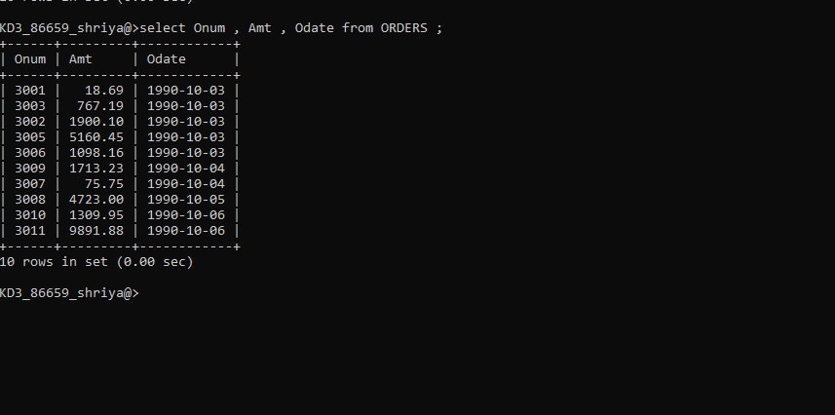

**Q2-** Write a query that produces all rows from the customers table for which the salesperson’s number is 1001.

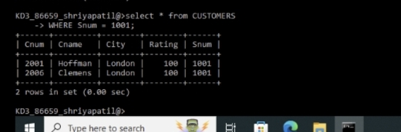

**Q3-** Write a query that displays the salespeople table with the columns in the following orders : city,sname,snum,comm .

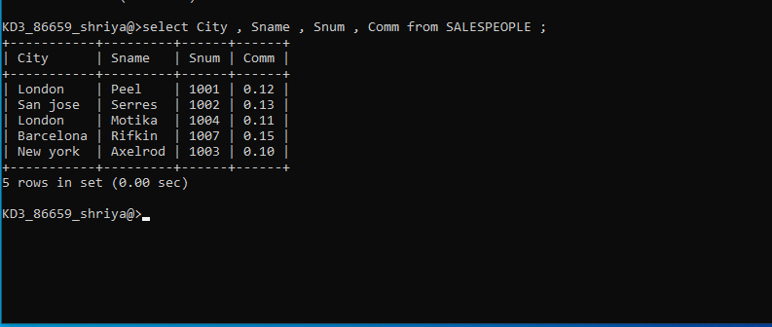

Q4- Write a select command that produces the rating followed by name of each customers in san jose .

